Week 3 Progress Report

# What was done last week:

* Had our first meeting to discuss our backgrounds, schedules and the project as a whole.
* Setup regular group meeting time, will occur every Monday at 7pm
* Emailed the client to introduce the group, organise our first meeting and organise regular meetings.
* Created Trello Kanban board to track and organise our progress.
* Created a Google Drive centre to hold documentation

The initialised trello board is shown below:

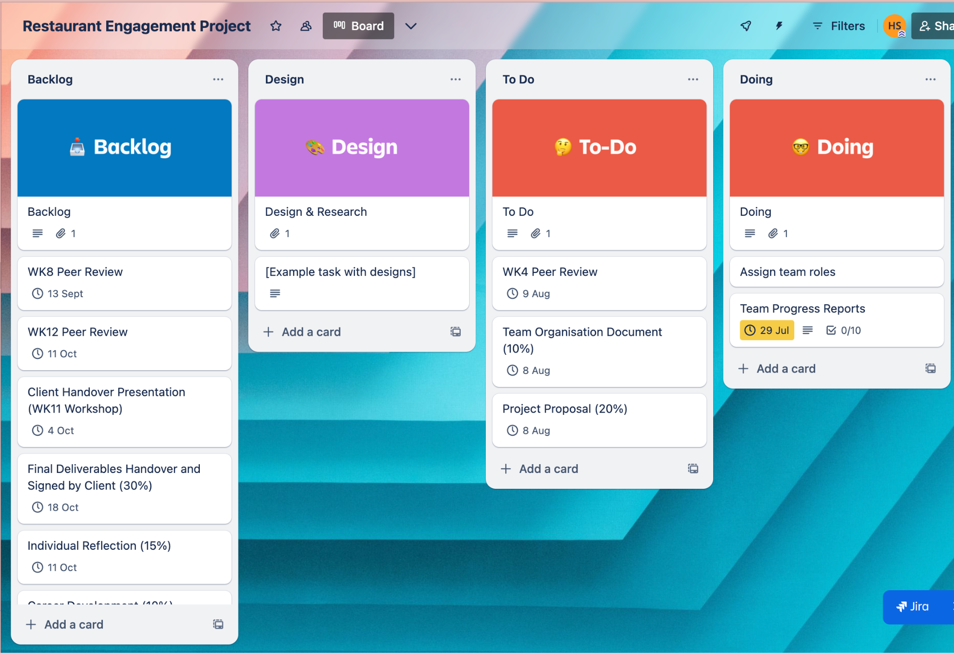

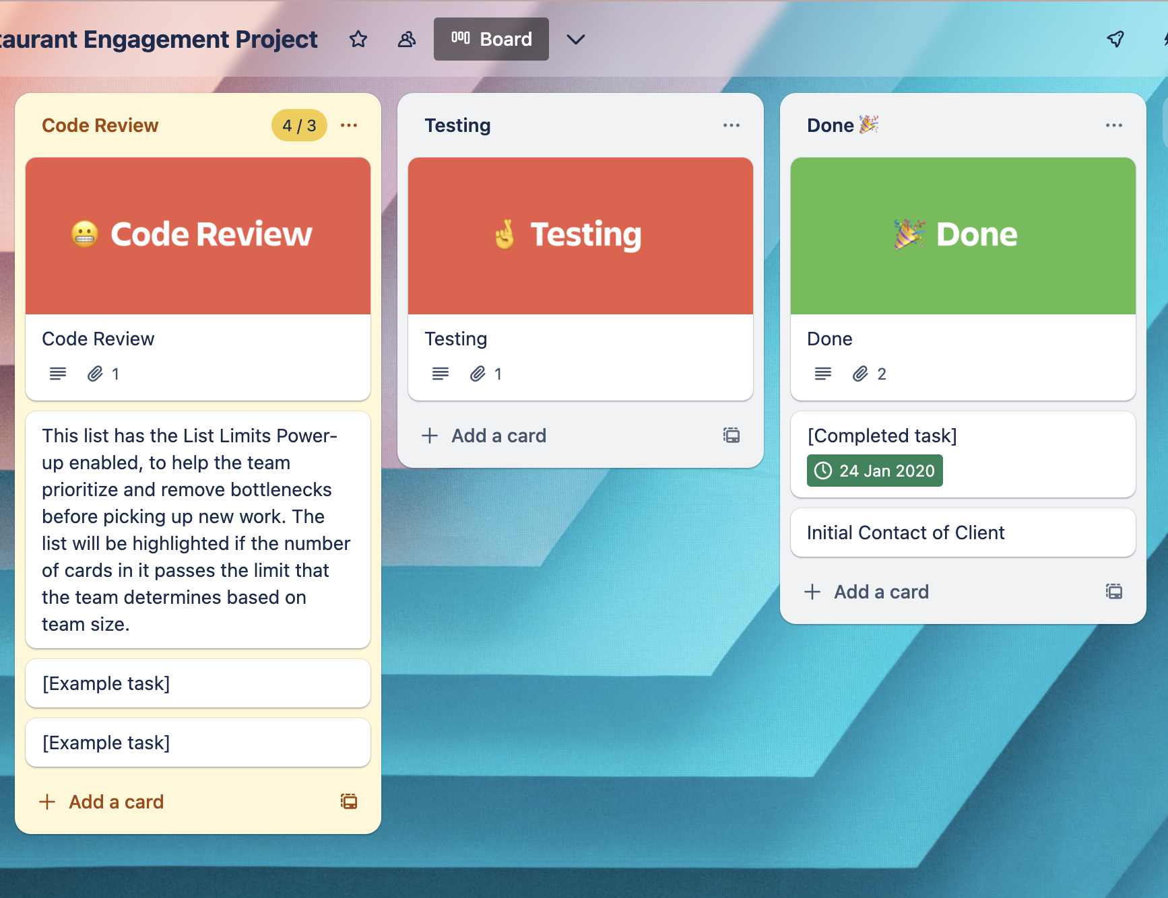

# Google Drive proof:

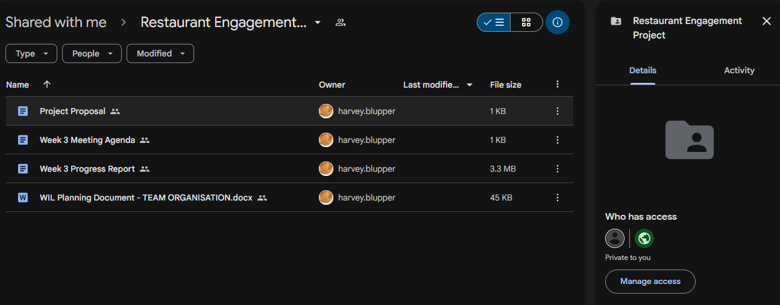

# What will be done this week:

* Assign and finalise team member roles.
* Meet with the client where the client liaison will introduce the team and the project requirements will be discussed and clarified
* Begin work on the team organisation document
* Begin work on the project proposal
* Look at the peer review and each team member will start to get an idea of how they will decide to fill it out.
* If time allows, create a concise requirements list that will outline must do requirements, non essential requirements and requirements that will only be completed if time allows.